**BANK LOAN REPORT QUERY DOCUMENT**

**A.BANK LOAN REPORT | SUMMARY**

**KPI’s:**

**Total Loan Application:**





**MTD_Total Loan Application:**





**PMTD_Total Loan Application:**





**MTD_Total_Funded_Amount:**





**PMTD_Total_Funded_Amount:**





**Total_Amount_Received:**





**MTD_Total_Amount_Received:**





**PMTD_Total_Amount_Received:**





**Avg_Interest_Rate:**





**MTD_Avg_Interest_Rate:**





**PMTD_Avg_Interest_Rate:**





**Avg_DTI:**





**MTD_Avg_DTI:**





**PMTD_Avg_DTI:**





**Good_Loan_Percentage:**

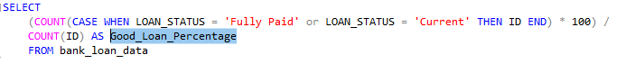



**Good_Loan_Applications:**





**Good_Loan_Funded_Amount:**





**Good_Loan_Received_Amount:**





**Bad_Loan_Percentage:**

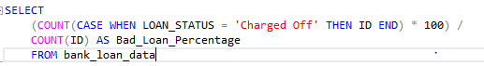



**Bank_Bad_Loan_Applications:**





**Bank_Bad_Loan_Funded_Amount:**





**Bank_Bad_Loan_Received_Amount:**

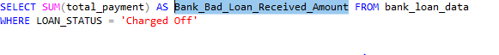



**GRID VIEW:**

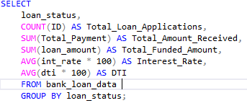

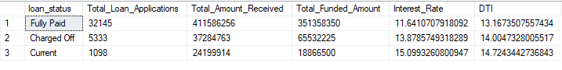

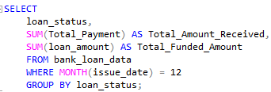

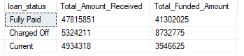

**Monthly Trends by Issue_Date:**

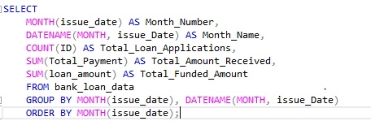

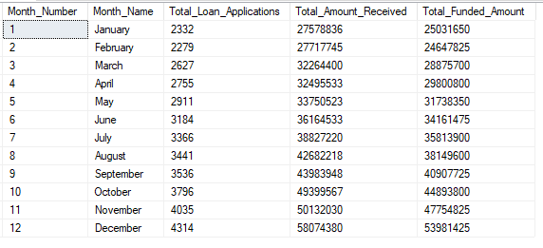

**Regional Analysis by State:**

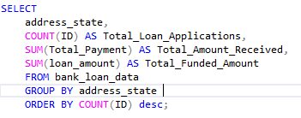

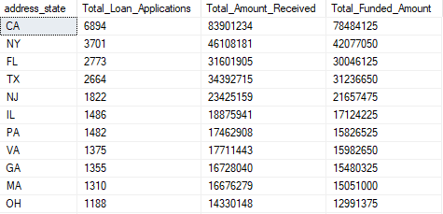

**Loan Term Analysis:**

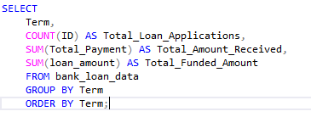

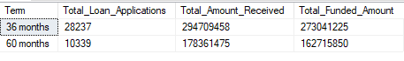

**Employee Length Analysis:**

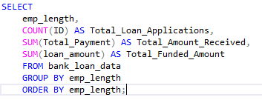

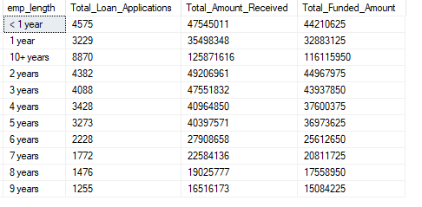

**Loan Purpose Breakdown:**

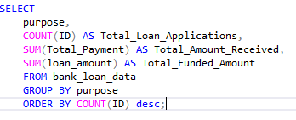

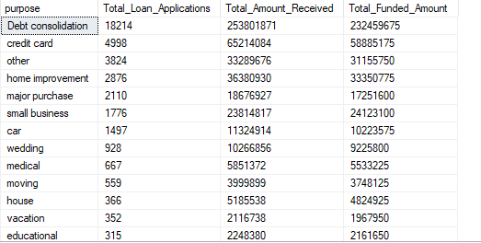

**Home Ownership Analysis:**

